

**FUNDAMENTAL OF PROGRAMMING**

***LAB MANUAL 10***

**LAB TASKS**

**NAME :** Daniyal Ahmed

**CLASS :** ME-15

**SECTION :** B

**CMS ID :** 457165

**DATE:**27/12/2023

**TASK 1**

#include <iostream>

#include <vector>

using namespace std;

int main(){

    vector<int> v;

    vector<int>::iterator rem=v.begin()+5;

    for(int i=1; i<11; i++){

        v.push_back(i);

    }

    cout<<"The values in the vector are: \n";

    for(vector<int>::iterator i=v.begin(); i!=v.end(); i++){

        cout<<*i<<'\t';

    }

    cout<<endl;

    v.push_back(5);

    rem=v.begin()+5;

    v.erase(rem);

    cout<<"After pushing 5 and removing integer at posiiton 5"<<endl;

    for(vector<int>::iterator i=v.begin(); i!=v.end(); i++){

        cout<<*i<<'\t';

    }

    return 0;

}

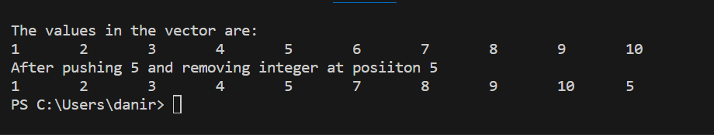

**TASK 2**

#include <iostream>

#include <vector>

#include <string>

using namespace std;

int main(){

    vector<string> name;

    string iname, temp_name;

    vector<int> grade;

    vector<int> mode_score;

    int igrade, sum=0, mean=0, temp=0, temp_grade=0;

    cout<<"Input the name and grade of each student."<<endl

        <<"Input backslash 0 in the name and any charecter in the grade to stop inputs."<<endl;

    while(cin>>iname && cin>>igrade){

        name.push_back(iname);

        grade.push_back(igrade);

    }

    cout<<"The values in the array are: \n";

    for(int i=0; i<name.size(); i++){

        cout<<name[i]<<"\t"<<grade[i]<<endl;

    }

    for(int i=0; i<grade.size(); i++){

        sum+=grade[i];

    }

    for(int i=0; i<grade.size(); i++){

        mode_score.push_back(0);

    }

    for(int i=0; i<grade.size(); i++){

        for(int j=1; j<grade.size(); j++){

            if(grade[i]>grade[j]){

                temp_grade=grade[i];

                grade[i]=grade[j];

                grade[j]=temp_grade;

                temp_name=name[i];

                name[i]=name[j];

                name[j]=temp_name;

            }

        }

    }

    cout<<"The median score is: ";

    if(grade.size()%2==0){

        cout<<endl<<grade[grade.size()/2]<<endl;

    }

    else{

        cout<<grade[((grade.size()/2)+((grade.size()/2)-1))/2]<<endl;

    }

    mode_score.resize(grade.size());

    mean=sum/grade.size();

    for(int i=0; i<grade.size(); i++){

        for(int j=0; j<grade.size(); j++){

            if(grade[i]==grade[j]){

                mode_score[i]++;

            }

        }

    }

    for(int i=0; i<mode_score.size()-1; i++){

        if(mode_score[i]>temp){

            temp=mode_score[i];

        }

    }

    cout<<endl<<"The mean of the grades is :"<<mean<<endl;

    cout<<endl<<"The most repeated score and their scorer are: \n";

    for(int i=0; i<grade.size(); i++){

        if(mode_score[i]==temp){

            cout<<name[i]<<'\t'<<grade[i]<<endl;

        }

    }

    return 0;

}

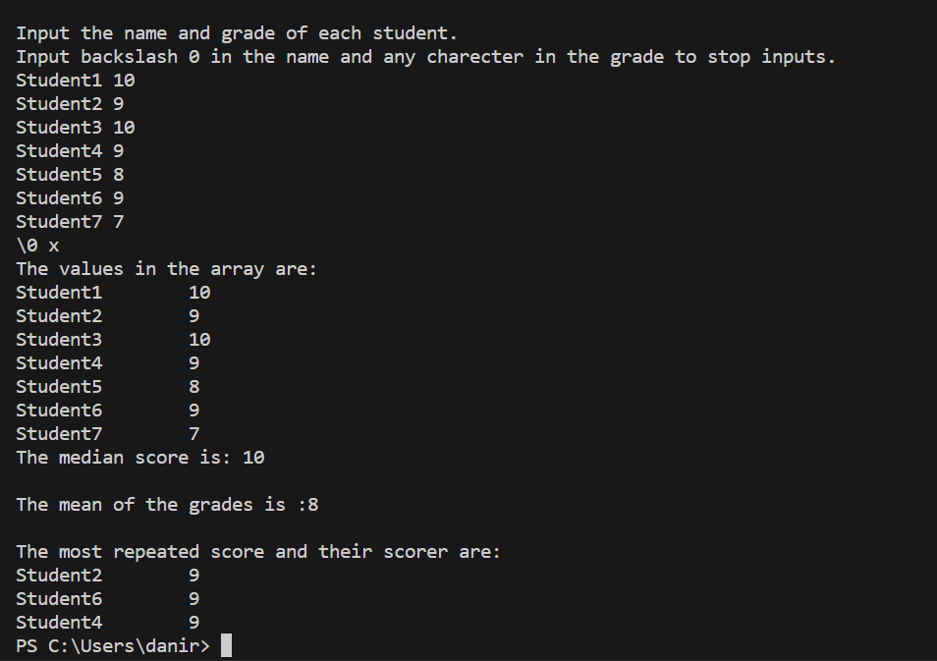

**TASK 3**

#include <bits/stdc++.h>

using namespace std;

class Triangle{

    public:

        float dimension1, dimension2, dimension3;

    float area(){

        double s=(dimension1+dimension2+dimension3)/2;

        return (sqrt(s*(s-dimension1)*(s-dimension2)*(s-dimension3)));

    }

    float perimeter(){

        return dimension1+dimension2+dimension3;

    }

};

int main(){

    Triangle triangle;

    cout<<"\n"<<"Enter dimension 1: ";

    cin>>triangle.dimension1;

    cout<<"Enter dimension 2: ";

    cin>>triangle.dimension2;

    cout<<"Enter dimension 3: ";

    cin>>triangle.dimension3;

    cout<<"The area of the triangle is: "<<triangle.area()<<endl;

    cout<<"The perimeter of the triangle is: "<<triangle.perimeter()<<endl;

    return 0;

}

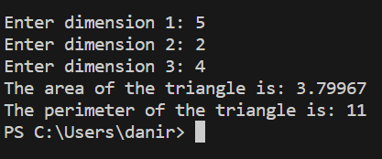

**TASK 4**

#include <iostream>

#include <string>

using namespace std;

struct EmployeeSalary {

    string emp_name;

    int base_payment, working_hours, total_salary;

    void calculateSalary() {

        if (working_hours < 8) {

            total_salary = base_payment;

        } else if (working_hours < 10 && working_hours >= 8) {

            total_salary = base_payment + 50;

        } else if (working_hours < 12 && working_hours >= 10) {

            total_salary = base_payment + 100;

        } else {

            total_salary = base_payment + 150;

        }

    }

};

int main() {

    int num_employees, check_entry;

    cout << "Input the number of employees: ";

    cin >> num_employees;

    EmployeeSalary employees[num_employees];

    for (int i = 0; i < num_employees; i++) {

        cout << "Input the Name, Base Payment, and Hours of Work Per Day of Employee number " << i + 1 << endl;

        cin >> employees[i].emp_name;

        cin >> employees[i].base_payment;

        cin >> employees[i].working_hours;

        employees[i].calculateSalary();

    }

    cout << "Input the entry number to check employee salary: \n"

         << "Input a character to exit \n";

    do {

        cin >> check_entry;

        if (check_entry >= 1 && check_entry <= num_employees) {

            cout << employees[check_entry - 1].emp_name << '\t'

                 << employees[check_entry - 1].working_hours << '\t'

                 << employees[check_entry - 1].total_salary << '\n';

        } else {

            cout << "Entry number does not exist." << endl;

        }

    } while (!cin.fail());

    return 0;

}

